The Islamia University Bahawalpur
(Department of Software Engineering)


PROJECT SRS
Title: “ FinSage – AI-Powered Money Management App ”
Submitted By
Usman Farooq
Roll No
F22BINFT1M01202
BSIT 7th (M3)
Supervisor
Ms. Sara Farid
(Lecturer, Department of Information Technology at IUB)
Date of Submission: December 05, 2025
Session: 2022 – 2026

Table of Content
1. Introduction 1
1.1 Introduction 1
1.2 Purpose 1
1.3 Document Conventions 1
1.4 Intended Audience and Reading Suggestions 1
1.5 Project Scope 2
1.6 Definitions, Acronyms, and Abbreviations 2
2. Overall Description 3
2.1 Product Perspective 3
2.2 Product Functions 3
2.3 User Classes and Characteristics 4
2.3.1 General Users (Primary Users) 4
2.3.2 Insight-Seeking Users 4
2.3.3 Savings-Focused Users 4
2.4 Operating Environment 4
2.5 Design and Implementation Constraints 5
2.6 Assumptions and Dependencies 5
3. System Features 7
3.1 User Authentication 7
3.1.1 Description 7
3.1.2 Functional Requirements 7
3.2 Dashboard 7
3.2.1 Description 7
3.2.2 Functional Requirements 7
3.3 Expense Management 7
3.3.1 Description 7
3.3.2 Functional Requirements 8
3.3.3 Budget Planning 8
3.3.4 Description 8
3.3.5 Functional Requirements 8
3.4 AI Insights 8
3.4.1 Description 8
3.4.2 Functional Requirements 8
3.5 Savings Goals 9
3.6 Bill Reminders 9
3.6.1 Description 9
3.6.2 Functional Requirements 9
4. External Interface Requirements 10
4.1 User Interfaces 10
4.2 Hardware Interfaces 10
4.3 Software Interfaces 10
4.4 Communication Interfaces 11
5. Non-Functional Requirements 12
5.1 Performance Requirements 12
5.2 Safety Requirements 12
5.3 Security Requirements 12
5.4 Software Quality Attributes 12
5.5 Reliability Requirements 13
5.6 Maintainability Requirements 13
5.7 Portability Requirements 13
6. System Models 14
6.1 Use Case Diagram 14
6.2 Use Case Descriptions 15
6.3 Data Flow Diagrams (DFD) 15
6.4 Entity–Relationship Diagram (ERD) 18
6.5 Class Diagram 18
6.6 Sequence Diagrams 21
Example 1: Adding an Expense 21
Example 2: Budget Notification 22
6.7 Activity Diagrams 23
Activity 1: Expense Tracking 23
Activity 2: Savings Goal Monitoring 23
7. Appendices 24
7.1 Glossary 24
7.2 References 24
7.3 Supporting Information 25

Table of Content
Table 1 Functional Requirements Example (Feature: Expense Management) 9
Table 2 Hardware Requirements 11
Table 3 Performance Requirements 13
Table 4 Use Case Descriptions 15
Table 5 Entities and Attributes Table 18
Table 6 Classes and Methods Table 19
Table 7 Glossary 24

Introduction

Introduction
FinSage is an AI-powered money management application designed to help users understand, organize, and improve their financial habits. The system addresses the limitations of traditional budgeting tools by offering more than basic expense tracking. Through machine learning, FinSage analyzes spending patterns, predicts upcoming expenses, and provides personalized financial insights that support better decision-making. Built using Flutter and Firebase, the application ensures a secure, scalable, and user-friendly environment for handling personal financial data. The goal of FinSage is to deliver an intelligent, intuitive, and reliable solution that empowers users to manage their finances with greater clarity, confidence, and control.

Purpose
The purpose of this SRS document is to define the functional and non-functional requirements of FinSage – AI-Powered Money Management App. It provides a clear and structured description of the system’s objectives, features, constraints, and expected behavior. The goal is to ensure a shared understanding among developers, testers, supervisors, and stakeholders as the system is designed and implemented. This document establishes a foundation for building an intelligent financial management application that delivers personalized insights, accurate expense tracking, and an intuitive user experience.

Document Conventions
This SRS document follows the IEEE standard structure and uses a hierarchical numbering format (1, 1.1, 1.1.1) to clearly organize requirements and subsections. Functional requirements are labeled using the prefix FR- and non-functional requirements using NFR- for easy identification. Standard engineering terminology such as user, system, expense, budget, AI insights, and savings goals is used consistently throughout the document. All diagrams, tables, and figures follow a uniform captioning style and are referenced using their defined numbers.

Intended Audience and Reading Suggestions
This document is intended for all stakeholders involved in the development and evaluation of the FinSage – AI-Powered Money Management App. The primary audience includes:
- Developers: To understand system requirements, core features, data structures, and technical constraints needed for implementation.
- Testers: To derive test cases and validation procedures based on functional and non-functional requirements.
- Supervisors and Evaluators: To review the system’s scope, objectives, and alignment with academic and technical standards.
- Project Stakeholders: To gain clarity on the system’s capabilities, limitations, and expected outcomes.

Project Scope
FinSage is designed to be a comprehensive AI-powered money management application that enables users to track expenses, plan budgets, monitor savings goals, and receive personalized financial insights. The system provides an intuitive interface, real-time analytics, and automated reminders, helping users make informed financial decisions. The project focuses on cross-platform accessibility via mobile devices, ensuring security, reliability, and scalability. By leveraging AI and machine learning, FinSage aims to transform raw financial data into actionable insights, offering a smarter and more efficient approach to personal finance management.

Definitions, Acronyms, and Abbreviations
This section provides the definitions and abbreviations used throughout the SRS to ensure clarity and consistency.
- AI: Artificial Intelligence used to generate insights and analyse spending patterns.
- ML: Machine Learning algorithms applied for financial predictions.
- UI: User Interface of the FinSage mobile application.
- UX: User Experience and overall interaction flow.
- FinSage: The proposed AI-powered money management mobile application.
- User: Any individual who interacts with the application to manage personal finances.
- Expense Tracking: Recording daily, weekly, or monthly financial transactions.
- Budget Planning: Creating and managing personalized spending limits.
- Firebase: Backend platform used for authentication, database, and cloud services.
- Firestore: NoSQL cloud database used to store user financial data.

Overall Description

Product Perspective
FinSage is a standalone mobile application designed to provide an intelligent and user-friendly platform for personal financial management. Positioned as a modern alternative to traditional budgeting tools, the system integrates AI-driven analytics, automated tracking, and predictive financial insights to enhance user decision-making. FinSage operates within a client–server architecture, where the mobile app serves as the client and Firebase provides backend services such as authentication, real-time database management, cloud storage, and analytics. The application is built using Flutter for cross-platform compatibility, ensuring a consistent experience across both Android and iOS devices. FinSage functions as an independent system but can integrate with external data sources like bank-imported statements or manual user entries to create a complete financial profile.

Product Functions
FinSage provides a comprehensive set of functions that help users manage their personal finances intelligently and efficiently. The core functions of the system include:
- User Authentication: Secure account creation, login, and user data protection using Firebase Authentication.
- Expense Tracking: Allows users to record, categorize, and view their daily, weekly, and monthly expenses in a structured format.
- Budget Planning: Enables users to create customized budgets, set spending limits, and monitor budget performance.
- AI-Powered Insights: Uses AI and machine learning to analyze spending patterns and deliver personalized financial recommendations.
- Savings Goal Management: Allows users to create, track, and update savings goals with progress visualization.
- Bill Reminders: Sends timely notifications for upcoming bills, due dates, and recurring payments.
- Interactive Dashboard: Provides a real-time overview of expenses, budgets, goals, and insights in a visually intuitive interface.
- Data Backup & Sync: Ensures secure storage and syncing of user financial data across devices using Firebase Firestore.

User Classes and Characteristics
FinSage is designed for individuals who want to manage their personal finances more effectively using intelligent and automated tools. Based on the project’s objectives and problem description, the system identifies the following primary user class:

General Users (Primary Users)
These are everyday individuals who need a simple yet intelligent solution for managing income, expenses, budgets, and savings.
Characteristics:
- Little to moderate financial knowledge
- Prefer automated tracking rather than manual budgeting
- Need clear, meaningful financial insights rather than just raw data
- Expect reminders for bills, predictive insights, and budgeting help
- Value a clean, intuitive, mobile-friendly UI

Insight-Seeking Users
Users who rely on AI-generated recommendations to improve their financial habits.
Characteristics:
- Interested in spending pattern analysis
- Want future expense predictions and warnings about risky spending
- Engage frequently with dashboards and visual analytics

Savings-Focused Users
Individuals motivated to set and track savings goals.
Characteristics:
- Require progress visualization and goal management
- Use the app consistently to monitor financial improvement

Operating Environment
FinSage will operate as a cross-platform mobile application, compatible with both Android and iOS devices. The system will be developed using Flutter for the frontend and Firebase for backend services, including Firestore for data storage and authentication. Users will require internet connectivity for real-time synchronization, AI-powered insights, and cloud-based data access. The application is designed to function efficiently on devices with standard hardware specifications, ensuring smooth performance on smartphones and tablets with at least 2 GB RAM and Android 8.0 / iOS 12 or higher. Security protocols and encryption mechanisms will protect sensitive user financial data both locally and in the cloud.

Design and Implementation Constraints
The design and implementation of FinSage must adhere to several constraints to ensure functionality, usability, and maintainability:
- Platform Constraint: The system will be developed as a cross-platform mobile application using Flutter, ensuring compatibility with both Android and iOS devices.
- Backend Constraint: Firebase and Firestore will be used for data storage and authentication, limiting the system to the capabilities and limitations of these services.
- Security Constraint: All sensitive user data, including financial transactions and personal information, must be securely stored and transmitted, complying with standard encryption and authentication practices.
- Performance Constraint: The application must provide real-time expense tracking and AI-based insights without noticeable delays on standard mobile devices.
- Resource Constraint: The application should optimize memory and battery usage to maintain acceptable performance on devices with limited resources.
- Third-Party Libraries: The system will rely on selected libraries for AI functionality and UI components; updates or deprecation of these libraries may affect system behavior.
- Implementation Constraint: The design must follow modular, maintainable, and scalable coding practices to support future enhancements and AI model integration.

Assumptions and Dependencies
The development and proper functioning of FinSage rely on the following assumptions and dependencies:
- Users will have access to a compatible mobile device with an internet connection.
- The application depends on Firebase services, including Firestore, for data storage and user authentication.
- AI-driven features assume access to sufficient historical and real-time user data for accurate insights and predictions.
- The system assumes users will provide accurate financial data for meaningful analysis.
- Development and deployment are dependent on Flutter’s cross-platform framework and associated libraries.
- Third-party APIs or services (e.g., for currency exchange rates or notifications) must remain available and operational.
These assumptions and dependencies are critical to ensure the system meets its intended functionality and performance requirements.

System Features

User Authentication

Description
The system shall provide a secure authentication mechanism to ensure that only authorized users can access their personal financial data. This includes user registration, login, and password management. Authentication will leverage Firebase Authentication for security and real-time access control.

Functional Requirements
- FR1: Users can register with a unique email and password.
- FR2: Users can log in securely using their credentials.
- FR3: Passwords shall be encrypted and securely stored using Firebase Authentication.
- FR4: Users can reset their password via email verification.
- FR5: Optional multi-factor authentication for added security.

Dashboard

Description
The dashboard provides an overview of the user’s financial status, including balances, recent transactions, budgets, savings goals, and AI-generated insights. It serves as the central hub for accessing all features of FinSage.

Functional Requirements
- FR1: Display current account balance.
- FR2: Show summaries of recent expenses and income.
- FR3: Present interactive charts and graphs for spending patterns and trends.
- FR4: Provide quick navigation to expense management, budget planning, bill reminders, and savings goals.
- FR5: Display AI insights, such as recommendations for spending reduction or savings optimization.

Expense Management

Description
Users can record, edit, categorize, and track their expenses in real-time. The system will automatically classify expenses into categories and provide history and analysis to improve financial awareness.

Functional Requirements
- FR1: Users can add, edit, and delete expense records.
  - FR2: Expenses are categorized automatically (e.g., food, transport, utilities) and can be cstomized by the user.
- FR3: Users can view expense history by day, week, or month.
- FR4: System generates summaries and reports for total and category-wise spending.
- FR5: Highlight unusual spending patterns to alert users.

Budget Planning

Description
Budget planning allows users to set spending limits for various categories and monitor adherence. The system provides notifications when spending exceeds planned budgets, helping users maintain financial discipline.

Functional Requirements
- FR1: Users can create budgets for multiple expense categories.
- FR2: Notify users when spending exceeds budget limits.
- FR3: Visual comparison of planned vs. actual spending using charts.
- FR4: Allow dynamic adjustment of budgets based on user trends or AI suggestions.

AI Insights

Description
FinSage leverages AI to provide personalized financial recommendations. The AI analyzes historical spending patterns, predicts future expenses, and suggests actions to optimize savings and budgeting.

Functional Requirements
- FR1: Analyze past spending patterns to identify trends.
- FR2: Suggest ways to reduce unnecessary expenses.
- FR3: Forecast future expenses and cash flow based on user behavior.
- FR4: Provide actionable recommendations for achieving savings goals.

Savings Goals
3.6.1 Description
Users can define short-term and long-term savings goals. The system tracks progress and sends notifications to encourage consistent saving behavior.
3.6.2 Functional Requirements
- FR1: Users can set target amounts and deadlines for each savings goal.
- FR2: Display progress using visual indicators (e.g., progress bars).
- FR3: Notify users of milestones achieved or delays.
- FR4: Provide AI-based suggestions to adjust saving amounts to meet goals.

Bill Reminders

Description
Bill reminders help users manage recurring payments and avoid late fees. Notifications ensure timely payment of all bills.

Functional Requirements
- FR1: Users can schedule reminders for recurring bills.
- FR2: Send notifications via app alerts or email.
- FR3: Mark bills as paid automatically once confirmed.
- FR4: Display upcoming and overdue bills on the dashboard.
ID | Requirement | Priority | Description
FR1 | Add Expense | High | User can add a new expense with category and amount
FR2 | Edit Expense | High | User can modify details of an existing expense
FR3 | Delete Expense | Medium | User can remove an expense
FR4 | Categorize Expense | High | System automatically categorizes expenses
FR5 | View Expense History | Medium | Show daily, weekly, monthly summaries
Table 1Functional Requirements Example (Feature: Expense Management)

External Interface Requirements

User Interfaces
The system shall provide a user-friendly and intuitive interface to allow users to manage their finances efficiently. The interface will be cross-platform, built with Flutter, and will include responsive layouts for mobile and tablet devices.
Requirements:
- UI1: The dashboard shall display financial summaries, charts, budgets, savings goals, and AI insights.
- UI2: Forms shall allow users to add, edit, or delete expenses, budgets, savings goals, and bills.
- UI3: Graphical charts and reports shall clearly visualize trends and financial analysis.
- UI4: Navigation shall be simple, allowing easy access to all features.
- UI5: Notifications and alerts for bills, budgets, and savings milestones shall be displayed prominently.

Hardware Interfaces
FinSage will operate on standard consumer devices and does not require specialized hardware.
Requirements:
- HW1: Compatible with smartphones (Android and iOS), tablets, and desktop browsers.
- HW2: Minimum device requirements: 2 GB RAM, 100 MB storage, and stable internet access.
- HW3: Optional support for device notifications (push alerts) to deliver reminders.

Software Interfaces
The system interacts with software services and APIs to ensure real-time functionality, secure storage, and AI-driven insights.
Requirements:
- SW1: Integration with Firebase for authentication, real-time database, and cloud functions.
- SW2: Integration with email services for password recovery and bill reminders.
- SW3: Integration with AI/ML libraries (TensorFlow Lite / OpenAI API) for financial insights and predictions.
- SW4: Compatible with standard web browsers for web-based dashboards (Chrome, Firefox, Edge, Safari).

Communication Interfaces
FinSage requires network communication for data synchronization, notifications, and AI services.
Requirements:
- CI1: Use HTTPS for secure communication between client devices and Firebase servers.
- CI2: Real-time synchronization of financial data across multiple devices via Firebase.
- CI3: Push notifications for upcoming bills, budget alerts, and savings milestones.
- CI4: Optional integration with third-party financial APIs for enhanced predictive insights.

Device | Specification | Purpose
Smartphone | Android/iOS, 2 GB RAM, 100 MB storage | Mobile access to FinSage
Tablet | iOS/Android, 2 GB RAM | Larger screen access for dashboard
Desktop Browser | Chrome, Firefox, Edge, Safari | Optional web interface for financial overview
Table 2 Hardware Requirements

Non-Functional Requirements

Performance Requirements
- PR1: The system shall respond to user interactions within 2 seconds for any operation such as adding an expense, updating budgets, or fetching AI insights.
- PR2: The dashboard and financial summaries shall load completely within 3 seconds on standard mobile devices.
- PR3: The system shall support up to 10,000 concurrent users without performance degradation.
- PR4: AI insights shall be generated and displayed within 5 seconds of user request.

Safety Requirements
- SR1: The system shall ensure the safety of user financial data through secure authentication and encryption.
- SR2: Backup mechanisms shall prevent data loss due to accidental deletion or system failure.
- SR3: User inputs shall be validated to prevent data corruption or application crashes.

Security Requirements
- SEC1: All user credentials and sensitive financial data shall be encrypted using Firebase Authentication and Firestore security rules.
- SEC2: Data transmission shall use HTTPS to prevent interception.
- SEC3: Implement multi-factor authentication as an optional security feature.
- SEC4: AI-generated recommendations shall not expose any personally identifiable information to external systems.

Software Quality Attributes
- QA1: Usability: The application shall provide an intuitive interface with clear navigation and visual feedback.
- QA2: Scalability: The system shall accommodate increasing numbers of users and financial data growth without performance loss.
- QA3: Maintainability: Code shall follow standard Flutter and Firebase practices for easy updates and bug fixes.
- QA4: Portability: The application shall work on Android, iOS, and web browsers.

Reliability Requirements
  - REL1: The system shall maintain 99.5% uptime for users.
  - REL2: Data synchronization across devices shall be accurate and consistent.
  - REL3: In case of failures, the system shall recover automatically without data loss.

Maintainability Requirements
- MR1: The codebase shall be modular, following best practices for Flutter development.
- MR2: Clear documentation shall be provided for all modules, APIs, and AI integration components.
- MR3: Regular updates and patches shall be easy to deploy without affecting user data.

Portability Requirements
- PRT1: The system shall be deployable on Android and iOS mobile devices.
- PRT2: Web-based access shall be supported on standard desktop browsers.
- PRT3: Database and backend services shall be hosted on Firebase to ensure cross-platform availability.

Requirement ID | Requirement | Measure
PR1 | App response time for adding/editing expenses | ≤ 2 seconds
PR2 | Dashboard load time | ≤ 3 seconds
PR3 | AI insights generation | ≤ 5 seconds
PR4 | Maximum concurrent users supported | 10,000 users
Table 3 Performance Requirements

System Models

Use Case Diagram
Actors:
- User: Accesses all main features (dashboard, expenses, budgets, savings, bills).
- AI Engine: Provides financial insights and predictions.
- Notification Service: Sends reminders for bills and savings goals.
High-Level Use Cases:
- Register/Login
- Manage Expenses
- Create/Monitor Budgets
- Set/Track Savings Goals
- Receive AI Insights
- Bill Reminders and Notifications

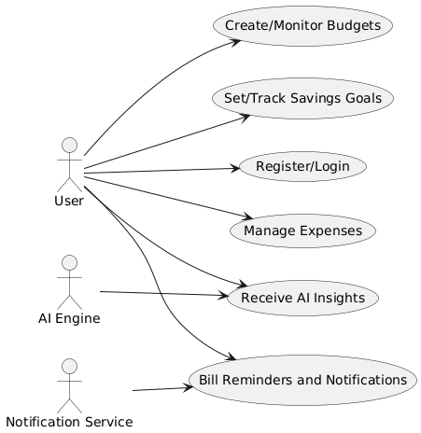
Figure 1 Use Case Diagram

Use Case Descriptions

Class | Attributes | Methods
User | userID, name, email, password | register(), login(), resetPassword()
Expense | expenseID, category, amount, date | addExpense(), editExpense(), deleteExpense()
Budget | budgetID, category, limit, period | createBudget(), updateBudget(), checkBudget()
SavingsGoal | goalID, targetAmount, deadline, progress | setGoal(), trackProgress()
BillReminder | billID, name, dueDate, status | setReminder(), sendNotification()
AIEngine | – | analyzeData(), generateInsights(), predictExpenses()
Table 4 Use Case Descriptions

Data Flow Diagrams (DFD)
Level 0 (Context Diagram):
- User interacts with the FinSage system.
- System communicates with AI Engine, Firebase Database, and Notification Service.
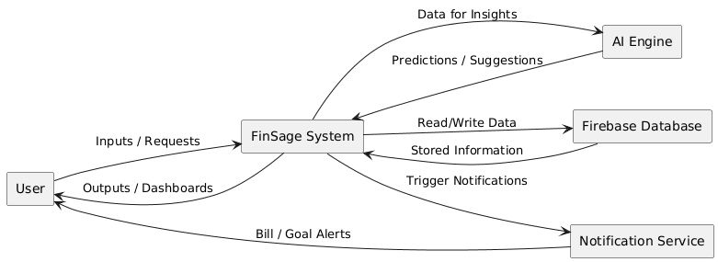
Figure 2 Level 0 (Context Diagram)

Level 1:
- Main processes: User Authentication, Expense Management, Budget Planning, Savings Goals, Bill Reminders, AI Insights.
- Data Stores: Firebase Firestore for expenses, budgets, savings, and user information.
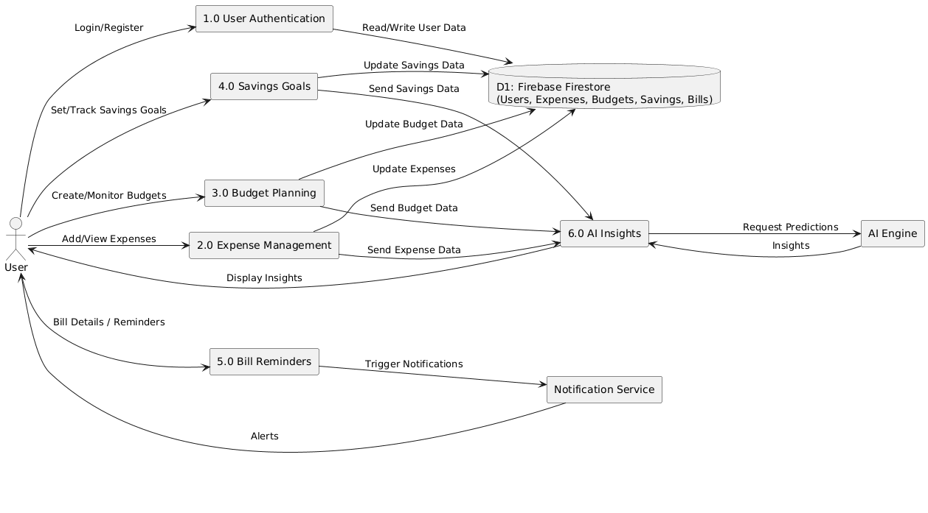
Figure 3 Level 1 (Context Diagram)

Level 2:
- Detailed flows for each module, e.g., Expense Management validates input → categorizes → stores → updates dashboard → triggers AI update.

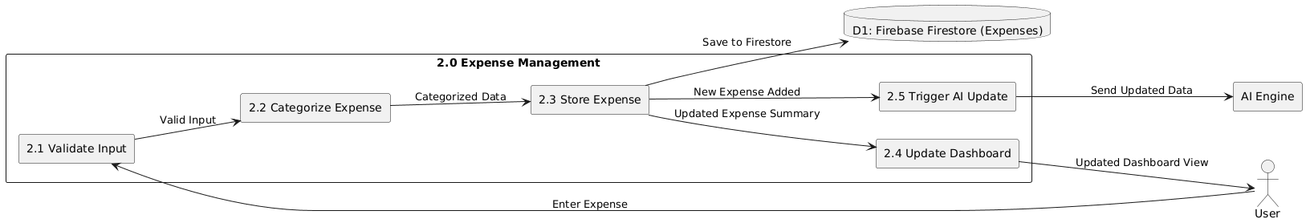
Figure 4 Level 2 (Context Diagram)

Entity–Relationship Diagram (ERD)

 | Attributes | Description
User | userID, name, email, password | Stores user information
Expense | expenseID, userID, category, amount, date | Stores user expenses
Budget | budgetID, userID, category, limit, period | Stores budget limits
SavingsGoal | goalID, userID, targetAmount, deadline, progress | Stores savings goal details
BillReminder | billID, userID, billName, dueDate, status | Stores bill reminders
Table 5 Entities and Attributes Table

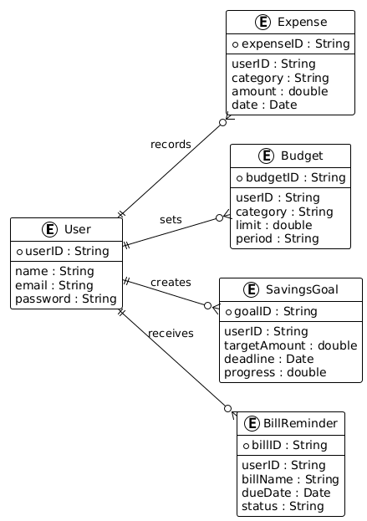
Figure 5 ER Diagram

Class Diagram

Class | Attributes | Methods
User | userID, name, email, password | register(), login(), resetPassword()
Expense | expenseID, category, amount, date | addExpense(), editExpense(), deleteExpense()
Budget | budgetID, category, limit, period | createBudget(), updateBudget(), checkBudget()
SavingsGoal | goalID, targetAmount, deadline, progress | setGoal(), trackProgress()
BillReminder | billID, name, dueDate, status | setReminder(), sendNotification()
AIEngine | – | analyzeData(), generateInsights(), predictExpenses()
Table 6 Classes and Methods Table
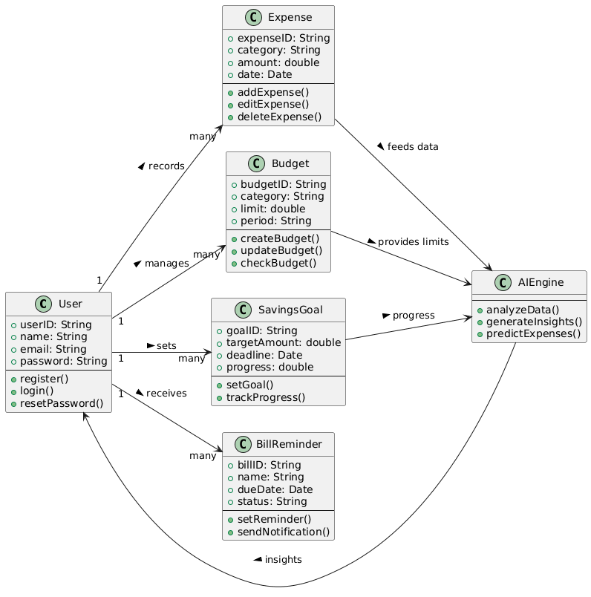
Figure 6 Class Diagram

Sequence Diagrams

Example 1: Adding an Expense
- User enters expense details.
- System validates input.
- Expense stored in Firebase Firestore.
- Dashboard updates totals and charts.
- AI Engine analyzes data and updates insights.

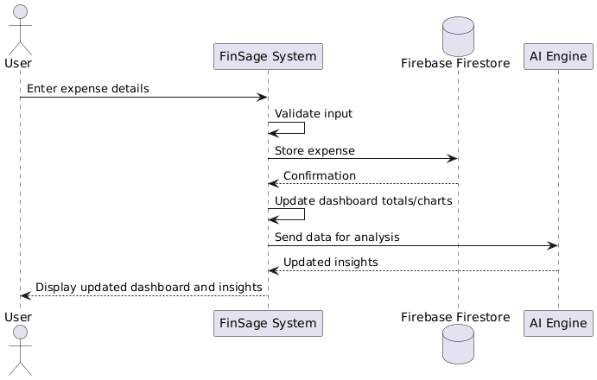
Figure 7 Sequence Diagrams (1)

Example 2: Budget Notification
- User sets budget limit.
- System tracks expenses.
- On exceeding limit, system triggers notification.
- User receives alert via app.

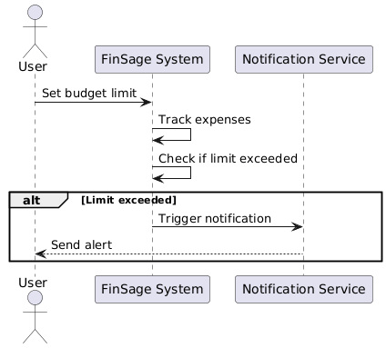
Figure 8 Sequence Diagram(2)

Activity Diagrams

Activity 1: Expense Tracking
- Start → Enter Expense → Validate → Categorize → Store in Database → Update Dashboard → End

Activity 2: Savings Goal Monitoring
- Start → Set Goal → Track Progress → Generate AI Recommendations → Notify User → End

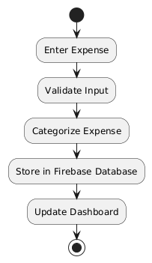
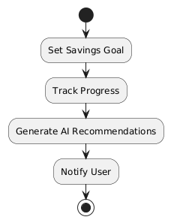
Figure 9 Activity Diagrams (1)
Figure 10 Activity Diagrams (2)

Appendices

Glossary

Term | Definition
FinSage | AI-powered personal finance management mobile application.
AI | Artificial Intelligence, used for predictive financial insights.
ML | Machine Learning, subset of AI for analyzing spending patterns.
Flutter | Cross-platform UI toolkit used for front-end development.
Firebase | Backend platform providing database, authentication, and cloud functions.
Firestore | Firebase’s cloud-based NoSQL database.
Budget | User-defined financial plan for tracking income and expenses.
Expense | Money spent by the user, categorized automatically by the system.
Savings Goal | Targeted amount a user wants to save within a specific time frame.
Dashboard | Main interface displaying financial summary, trends, and AI insights.
Bill Reminder | Notification system for upcoming bills and recurring payments.
Table 7 Glossary

References
- IEEE Std 830-1998, IEEE Recommended Practice for Software Requirements Specifications.
- Flutter Official Documentation: https://flutter.dev/docs
- Firebase Official Documentation: https://firebase.google.com/docs
- TensorFlow Lite Documentation: https://www.tensorflow.org/lite
- OpenAI API Documentation: https://platform.openai.com/docs
- Sommerville, I., Software Engineering, 10th Edition, Pearson, 2015.

Supporting Information
- Screenshots of UI wireframes and mockups (to be included).
- Sample datasets for AI/ML model training (expense and income data).
- Testing checklists and logs for unit, integration, and system testing.
- Security and privacy guidelines for handling user financial data.
- Agile sprint planning documents and project timeline.

